- How many entries in the countries table are from Africa?
The number of entries from Africa are 56.
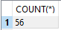
SELECT COUNT(*)
FROM countries
WHERE continent='Africa';
- What was the total population of the continent of Oceania in 2005?
The total population in 2005 in Oceania was 5281393mln
SELECT SUM(py.population) AS total_population, c.continent
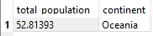
FROM population_years py
JOIN countries c
ON py.id=c.id
WHERE py.year=2005 AND continent='Oceania'

- What is the average population of countries in South America in 2003?

The average population in 2003 in South America is 0.00629mln

SELECT AVG(py.population) AS average_population , c.continent
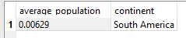
FROM population_years py
JOIN countries c
ON py.id=c.id
WHERE py.year=2003 AND continent='South America'

- What country had the smallest population in 2007?

The country with the small population in 2007 was Europe

SELECT MIN(py.population) AS min_population, c.name
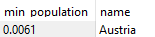
FROM population_years py
JOIN countries c
ON py.id=c.id
WHERE py.year=2007

- What is the average population of Poland during the time period covered by this dataset?

The average population during the time period covered by the database of Poland is 0.08563mln

SELECT AVG(py.population) AS avg_population, c.name

FROM population_years py
JOIN countries c
ON py.id=c.id
WHERE c.name='Poland';

- How many countries have the word “The” in their name?

The countries that contains the word ‘The’ in their name are 4

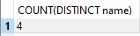
SELECT COUNT(DISTINCT name)
FROM countries
WHERE name LIKE '%The%';

- What was the total population of each continent in 2010?

The total population of each continent in 2010 is shown in the table:

SELECT ROUND(SUM(py.population),2) AS total_population, c.continent,py.year
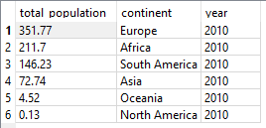
FROM population_years py
JOIN countries c
ON py.id=c.id
WHERE py.year=2010
GROUP BY 2
ORDER BY 1 DESC

